# Data Centric RAD

## Lab 5 Eclipse, Tomcat Installation

### NOTE: Parts 1 & 2 only need to be done if you are using your own laptops. This software is already installed in the computer labs.

### Part 1 - Eclipse

1. Download and unzip Eclipse IDE for Java EE Developers from <https://eclipse.org/downloads/eclipse-packages/>
2. Unzip the file just downloaded.
3. The Eclipse executable in called *Eclipse* and is located in the *eclipse* folder. This can be added to the Start Menu or the Desktop for easy access to Eclipse.

### Part 2 – Apache Tomcat

1. Goto <https://tomcat.apache.org/download-90.cgi> and download the **32-bit/64-bit Windows Service Installer** as shown.

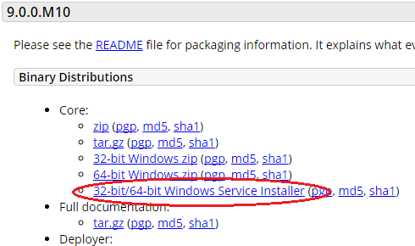

1. Click on the file just downloaded to begin the installation.
2. Click *Next*.
3. Click *I Agree*.
4. Select type of Installation **Normal**.
5. Click *Next*.
6. Click *Next* on the *Configuration Options* screen.
7. Set the JRE (Java Runtime Environment) Path e.g. *C:\Program Files\Java\jre1.8.0_101* and click *Next*.
8. Click *Install*.
9. Unselect *Show Readme* and click *Finish*.
10. Ensure the Tomcat icon is visible in the Windows toolbar as shown:

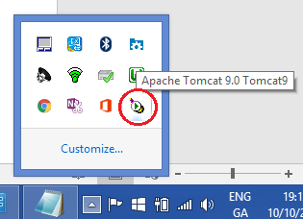

1. Open a browser and go to *localhost:8080* and you should see the Tomcat homepage as follows:

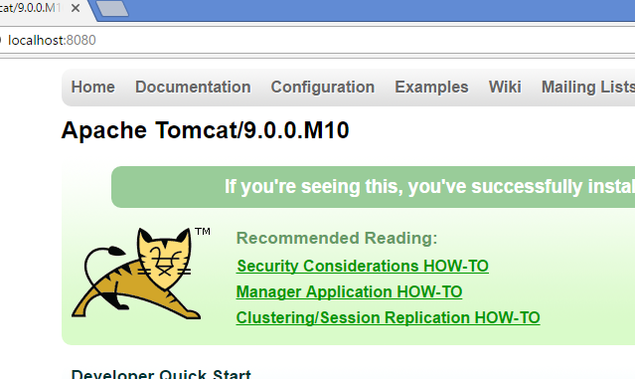

### Part 3 – Configure Apache Tomcat in Eclipse

1. Stop Tomcat by going to the bin folder in the Tomcat Installation folder e.g. cd C:\Program Files\Apache Software Foundation\Tomcat 9.0\bin

and type:

catalina.bat stop

* ~~If cmd is giving error about no Java_Home variable set do the following~~
* ~~Make sure JDK is installed usualy in C:\Program Files\Java (Use win explorer).~~
* ~~If JDK there then next step is use cmd type (echo %JAVA_HOME%) it will return %JAVA_HOME% if the enviorment variable isn’t set and C:\Program Files\Java\jdk1.8.0_101 if it is set.~~
* ~~If java home isn’t set then type (Set Java_Home=C:\Program Files\Java\jdk1.8.0_101)~~
* ~~Then (SET PATH = %PATH%;C:\Program Files\Java\jdk1.8.0_101\bin)~~
* ~~Try step on again.~~
* In search bar search “system variables”
* Click environment variables

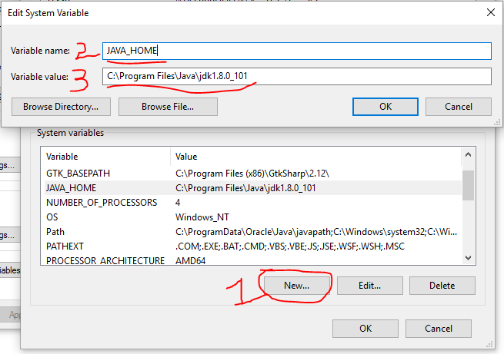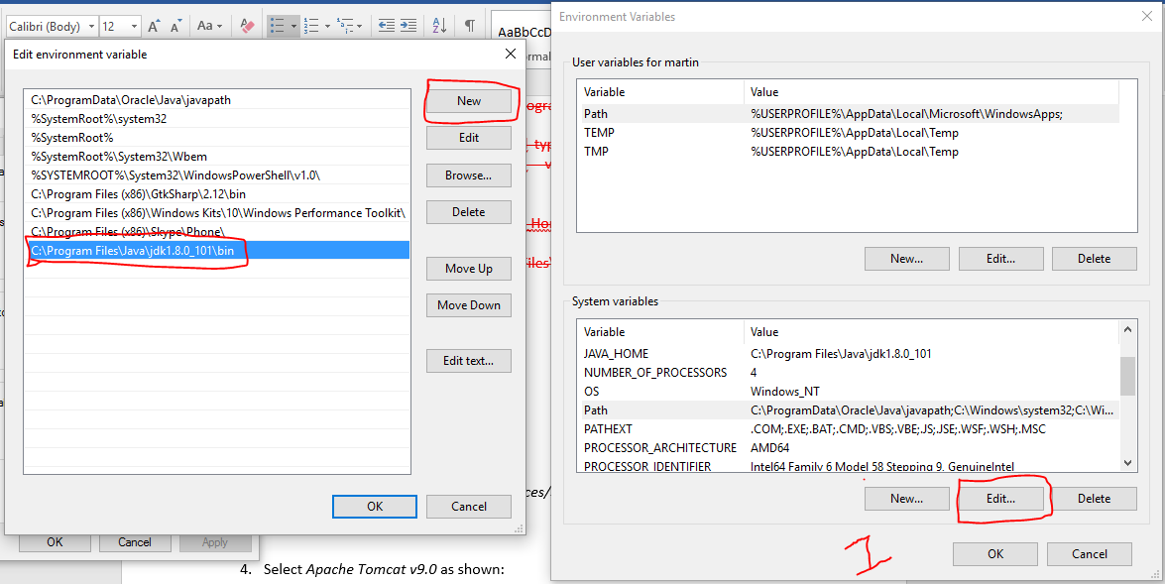

1. Open Eclipse and click *Window/Preferences/Server/Runtime Environment*.
2. Click *Add*.
3. Select *Apache Tomcat v9.0* as shown:

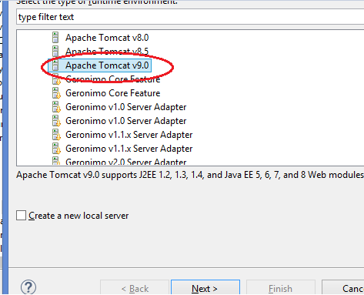

1. Click *Next*.
2. Click Browse to select the Tomcat installation directory (should be C:\Program Files\Apache Software Foundation\Tomcat 9.0).
3. Click *Finish*.
4. Click *OK*.
5. Open the Java EE Perspective in Eclipse (Window/Perspective/Open Perspective/Other and select Java EE).
6. Select the *Servers* tab at the bottom of the screen (1), then click on the link (2) as shown:

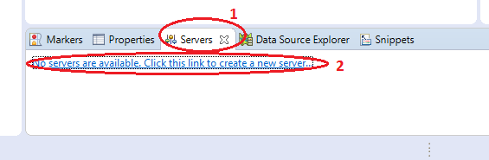

1. Select Tomcat v9.0 Server.
2. Click *Finish*.
3. Click on the Start button as shown:



1. After a few seconds the Tomcat server should be Started and Synchronized as shown:

